# How-To Store and Retrieve Files with Amazon S3

This document describes how to use the Amazon Simple Storage Service (S3) to perform simple actions on a given file or files. As you follow the steps, you will learn how to Store, Retrieve and Delete a file with S3.

1. [Create a free AWS account](https://portal.aws.amazon.com/gp/aws/developer/registration/index.html) if you don’t already have one.
2. [Click here](https://console.aws.amazon.com/console/home) to sign in to the AWS Management Console, with the username and password created in Step 1.
3. On the AWS Management console, enter S3 in the search bar under Find Services and select the service from the search result.
4. On the S3 Console, you will see a button labeled Create bucket. A bucket is the container where all the objects are stored.
5. Click on Create bucket and follow the wizard to complete the process.
   1. Enter a name for the bucket.
   2. Choose a Region to create the bucket in or continue with the default option.
6. Next, in the Configure Options step, you can enable features such as Versioning, Server Access Logging, Tags and a few others.
7. In the next step, you have the ability to Set permissions. Accept the default settings and move on to the next step.
8. In the last step, review all the settings and click Create bucket.
9. Once the bucket is successfully created, it will show up in the list of buckets on the S3 console (as shown in the screenshot below.) Click on the bucket name to get to the bucket dashboard.

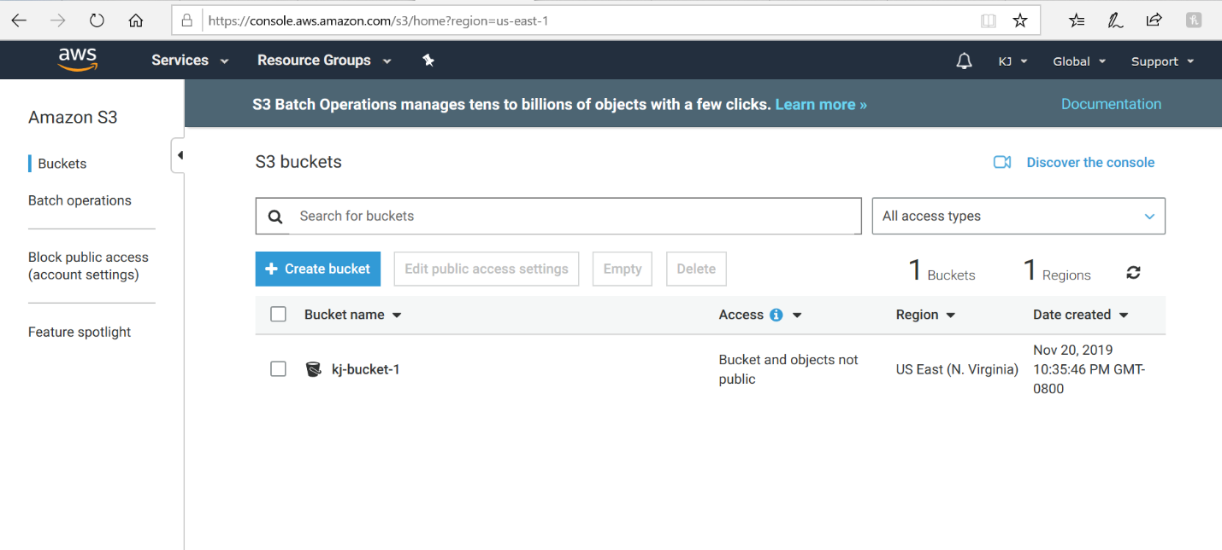

1. To add files to the newly created bucket, on the bucket dashboard, click on Upload.
2. Here you have the option to Drag and drop your files into the bucket or Add files by navigating the file system. Once added, you can edit the permissions and properties of the files by clicking Next or you can click Upload to accept the default values.
3. The uploaded files will now show up in the bucket where they were added.
4. To Retrieve the files from the bucket, simply select the file(s) to be downloaded and click the Download button.

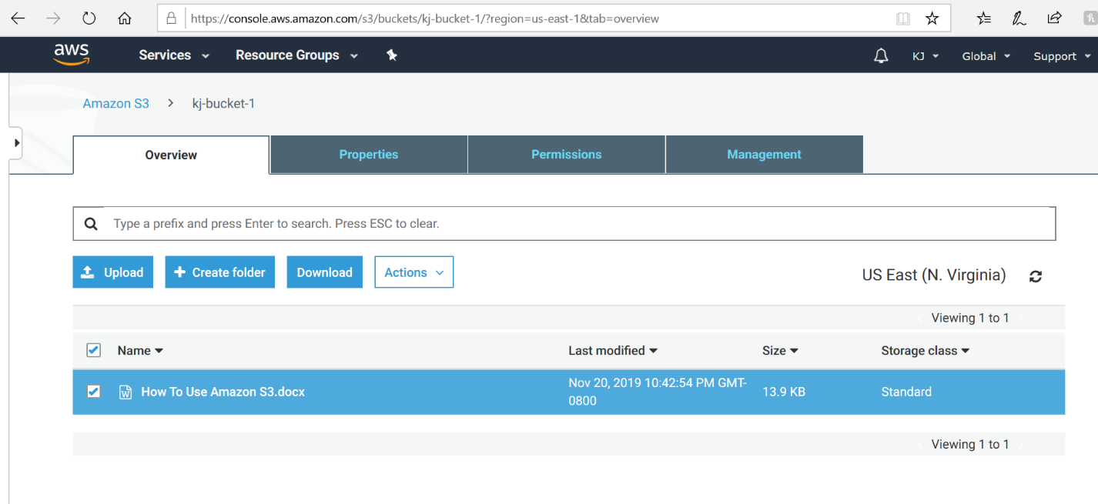

1. In order to delete the file from the bucket, select the file and click Delete from the Actions drop down menu. (Shown in the image below)

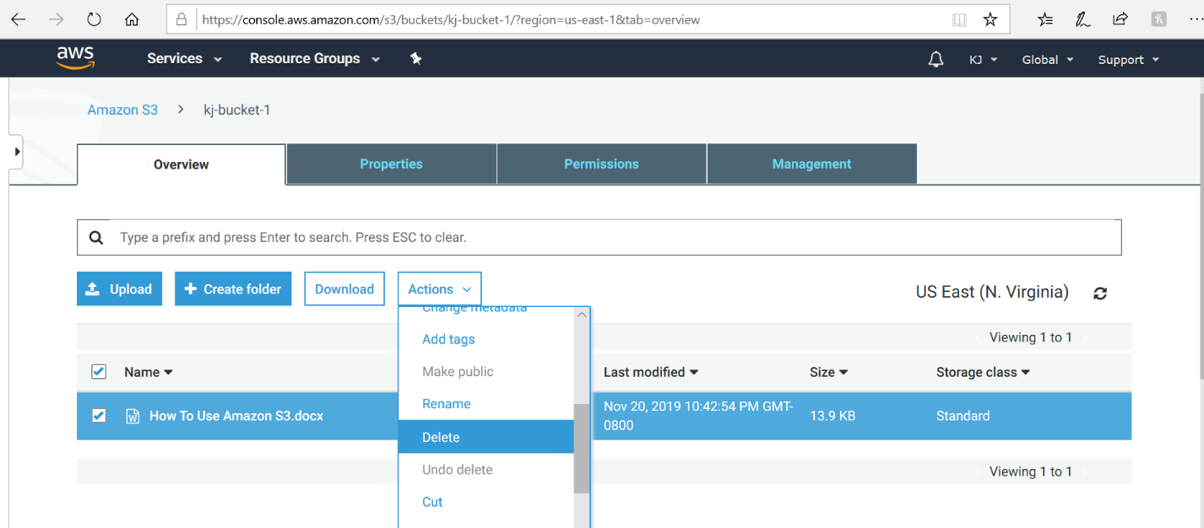

1. If you have Versioning enabled for this bucket, all the versions of the document(s) will be available for download as seen in the image below.

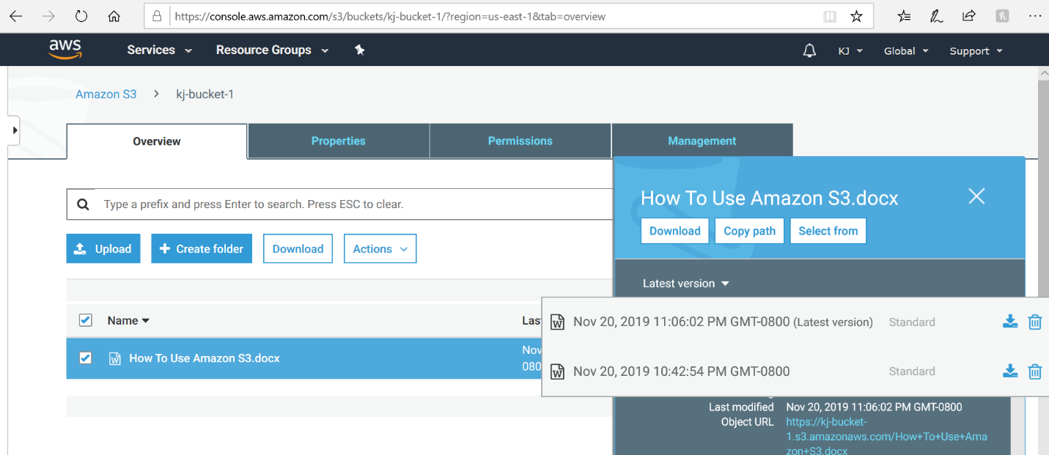

This completes a very basic tutorial of Amazon S3, establishing the fact that the S3 console is very intuitive and easy to use.